Compliments of
Linda Kent, M.Ed., N.C.

Certified Law of Attraction Coach
and Tong Ren Therapist
www.xxxx.xxx
248-373-9414

My Favorite Healthy Products

My Favorite Healthy Products

Compliments of Linda Kent

Certified Law of Attraction Coach
and Tong Ren Therapist
www.xxxx.xxx 248-373-9414

My Favorite Healthy Products

There are so many products on store shelves today that it’s often confusing to know which ones to purchase. I hope this booklet will introduce you to some new products and new information that you will find beneficial, and especially those of you who, like me are 60 or older and cannot afford to ingest more harmful chemicals or be in a toxic home environment. We can’t control everything but we can begin to take better care of ourselves by ingesting foods and buying products that are organic, non-GMO’s, low or no salt and very little, if any, sugar. Most of the products mentioned here can be found in health stores.

Learn to read labels. Labels list ingredients in descending order of predominance or weight. If the first ingredient on a label is sugar or white flour or fat, do not buy it. Some products list, “all natural ingredients” on the packaging. This might not be the case, so check this out for yourself.

Adjust the serving size. Adjust your size listed on the label according to how much will be consumed. Product servings are often given in much smaller amounts than will be consumed thus giving you a false sense of eating judiciously. Ingredients that have many letters and are difficult to pronounce can be things you don’t wish to put inside your body. The shorter the ingredient list the better; less man-made thing are put in that product.

BODY CARE 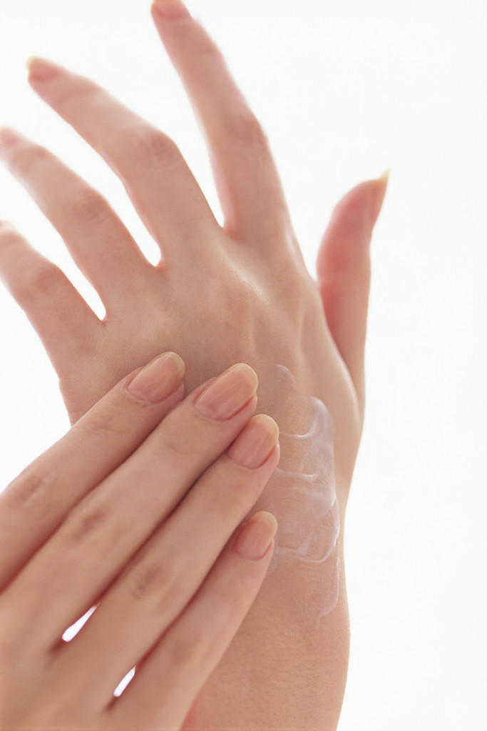

Hugo Naturals all over lotion.
This is a fabulous, organic clean product—I love the lemon verbena & bergamot.

Nubian Heritage body lotion.
I chose the raw shea butter with fransincense and myrrh---this product is never tested on animals.

Clearly Natural Essentials pure glycerin soap.
This is the soap I have used for years to wash my face in the morning and before going to bed---costs less than $2.00 and does the job.

Acure facial skin products.
You won’t find cleaner products than Acure—vegan, sulfate free, gluten free, 100% biodegradable, paraben free, organic.

evanhealy facial products.
Simply amazing---the facial serums stimulate circulation and create a rosy, tanned facial color ---many of the ingredients are produced by the small, self-governed Berber Woman’s Co-Operatives of Morocco-100% clean product.

Dr. Hauschka.
Pricey, pure products.

CLEANING PRODUCTS 

Window Clean by Earth Friendly Products.

Laundry Liquid by biokleen.

Heartland Natural Cleaning Solution also known as Planet Solutions.
This is my favorite cleaning product because it has so many uses. I use it for cleaning the bathroom, the carpet, washing fruits and vegetables, washing floors and keeping my toothbrush fresh. Other uses include: auto interior and exterior, bug bites, cleaning paint brushes, washing cats and dogs, removing blood stains and on and on….
Call 1-888-772-2345 or go to at www.heartlandnatural.com to order.

Bon ami cleanser
No chemicals, 4 ingredients, biodegradable

DENTAL PRODUCTS 

Xyliwhite Toothpaste Gel by Now.
Fluoride-free, clean product.

Power Smile by Jason.
No sodium lauryl laureth sulfates, no fluoride, no saccharin.

Oralive by Ascended Health.
Oral and balancing paste for the gums made of live edible clays, calcium, oxygen, trace minerals and more—messy but effective. www.Asccendedhealth.com

Natural Tooth cleaner.
Mix baking soda with Bragg’s or Spectrum’s organic, unfiltered apple cider vinegar for a fizzy tooth cleaner.

Herbal Mouthwash by Vita-Myr.
This product only uses 4 ingredients, zinc, folic acid, clove oil and myrrh in distilled water—a wonderful husband and wife team from Las Vegas run this company.
888-558-8482, www.vitamyr.com

Coconut Oil
After trying many teeth whitening products, coconut oil is the only thing that has whitened my two stained teeth and I continue to use it as needed.

DEODERANTS

I like to make my own chemical-free formula: mix baking soda and water into a paste and put it under your arms--- amazingly effective.

DIGESTION 

Enzymedica Digest
These are the current plant based enzymes I use, one at the beginning of lunch and dinner—vegan, kosher, no fillers.

Enzymes are not tangible, physical substances. Enzymes are the very life force that activates vitamins, minerals and proteins, pure energy. They are
naturally found in raw foods such as vegetables, fruits, nuts and seeds and, as such, are called “living foods”; these living foods break food down, carry nutrients to the cells and send nutrients to different parts of the body. When we are born, we have a constant supply of enzymes, however, as we age, the enzyme reserve starts to become depleted so it’s a good idea to take enzymes with your meals to ensure your food is broken down and can be used to rebuild the body.

inner-echo
Dairy-free probiotic kefir by Best of West found in the refrigerated section of your health store. Do not shake the bottle, just open gently. I love the fact that I can use this product once a day while I’ve had to take other probiotic products several times daily.

PB8 by Nutrition Now
Probiotics aid you in digesting your foods, support your immune system which is important since 80% of your immune system is in the gut and helps to keep a healthy balance of intestinal microflora.

FOODS

Longevity Bean Muffins by Longevity Foods
Made right here in Detroit. Ok, so you’re thinking muffins made of beans. Hmmm…these taste great, come in different flavors, 3 carbohydrates each, gluten free, fat free, sugar free, and sweetened with xylitol—you can add cinnamon or fruit or cocoa power as toppings if desired-- You can buy these muffins at Nutri Foods in Royal Oak, MI or call 248-416-8816.

Coconut Flour by Bob’s Red Mill-
A wonderful gluten-free alternative for baking that is a good source of protein and low in carbohydrates. Check out Dr. Bruce Fife’s book, Cooking with Coconut Flour for delicious tasting recipes like muffins, pancakes and, my favorite, pineapple upside-down cake… all healthy; all delectable.

Applegate turkey slices
No hormones or antibiotics.

Dietz & Watson turkey
No MSG, 99% fat free, low salt is available.

Salmon
Only wild salmon, never farm raised---choose Alaskan or Sockeye.

Chicken
You can purchase organic and free range chickens at Trader Joe’s. Usually you can only buy organic or free range so this is the place to go.

Beef
Grass fed

Eat animal protein in moderation; it can be hard on the kidneys and often leeches minerals from the bones.

Maca
A vegetable that is a hormone balancer and adaptogen, often called Peruvian Ginseng. You can purchase the best, organic, raw maca from Vita-Myr, 888-558-8482 or see www.vitamyr.com.

Marinara Sauce by Trader Joe’s
No salt, organic and very affordable; I add onions and garlic to the sauce.

Organic pacific Sushi Nori Sheets
This and the next food listed are for the adventurous diner. These sheets are the outer wrap you eat when you order sushi at a restaurant. This is my new wrap for just about any food and replaces the need for bread. I place salmon or cooked veggies or salad or nut butter, etc. wrapped in these sheets.

Kelp Noodles by Sea Tangle
These are very thin, squishy noodles that can be used on salads and also warmed with pasta sauce. I transfer the noodles to a jar filled with pure water and refrigerate them to use as needed.
The above two foods are nourishing to the thyroid.

Vegenaise
This fabulous product tastes like mayonnaise, looks like mayonnaise but is much healthier than mayonnaise—gluten-free, egg-free. I use the grapeseed oil because it raises the “good” cholesterol and tastes great.

Sonoma Veggie Burgers by Amy’s
Sonoma burgers are gluten free, dairy free, soy free (most veggie burgers contain soy so this is a real find), organic---many choices for your favorite toppings---

Kombucha by Millennium Products, Inc.
This amazing drink is organic, contains enzymes, probiotics and antioxidants, is vegan and is tastier than pop or soda. Please introduce this drink to your children and grandchildren. Be aware that some flavors like grape have a higher sugar content from fruits than other flavors.

Spectrum Virgin Coconut Oil
I have to include this amazing oil because of all the benefits it provides. New research indicates that because of the high percentage of medium chain triglycerides found in coconut oil, it possesses potent neuroprotective properties that can ease oxidative stress, inflammation and unbalanced glucose metabolism. The term “virgin” indicates that the product has undergone minimal processing which is good.

Chocolate 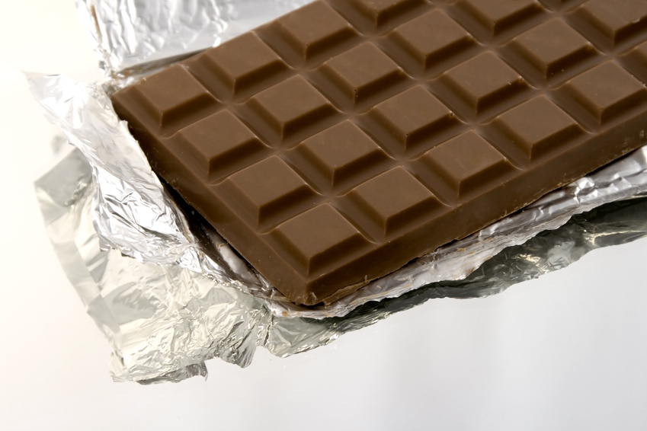
When you have good quality chocolate, you don’t need a lot of added sugar to feel the bliss that accompanies “the chocolate experience”. The higher the percentage of cacao, the less sugar added.

Righteously Raw
Pure dark chocolate, 83% raw cacao.

Green and Blacks
Organic, 85% cacao.

Endangered Species
Dark chocolate, some are organic, 72% cacao.

Ghiardelli
72% cacao.

OMEGA-3 FATTY ACIDS
Omega-3 fatty acids are a type of polyunsaturated fat that are essential for good health. Our bodies cannot produce these fatty acids so it’s important to supplement them into our diet.

Carlson Fish oil
Regularly tested for contamination.

Nordic Naturals Purified Fish Oil
Regularly tested for contamination.

STRESS RELIEF

Serenity by Kroeger Herbs-.
Kroeger Herbs are a wonderful line of products that I have used for years—order at Southern Herbs 1-800 795-1354 or purchase at Nutri- Foods, 248-541-6820 and Zerbo’s, 734-427-3144.

Skullcap by Herb Pharm
Liquid herbal extract.

Calm by Natural Vitality
Vegan, gluten-free and non-GMO. This is a magnesium powder that is easily absorbed by the body and helps keep calcium in balance. Calm has won supplement awards in 2011, 2012 and 2013. I like the raspberry-lemon flavor.

B-complex by Country Life

SEASONINGS 

Celtic Sea Salt
Provides a balance of 80 minerals and many trace elements. Hand-harvested, sun-dried whole salt from the costal regions of France.

Himalayan Salt
Zero exposure to toxins and impurities; rich in minerals and trace elements.

Table salt and iodized salt has important minerals removed during the refining process such as calcium and trace minerals. It can cause the body to retain fluids and can lead to inflammation of the tissues so instead, choose one of the products listed above.

Liquid Aminos by Bragg
Vegetable protein seasoning from non-GMO soybeans; contains 16 amino acids.

Simply Organic by Frontier Natural products
a clean line of spices that are wholesome and healthy. 1 % of sales support organic farming causes.

SUGAR SUBSITUTES

Coconut Palm Sugar
Low glycemic index (a scale of how foods impact the blood sugar); less processed than industrial sugars, unrefined.

Stevia
Does not cause an increase in blood sugar; 100% natural. It has been used medicinally for 1,500 years in South America with no reported side effects.

Pure Maple Syrup

Xylitol
Low glycemic index, fast dissolving.

Honey
Consume unrefined, unpasteurized raw honey in small amounts.

Aspartame found in gum, yogurt and many artificial sweeteners including Equal, NutraSweet or Spoonful should be avoided at all costs-this artificial sweetener has caused terrible, debilitating side effects.

High fructose corn syrup should also be avoided. Minimize your intake of all sugar substitutes.

“TOYS”

Aerobic Exercise Stress Buster by Evergain—
Improves blood circulation, increases lymphatic drainage, oxygenates the body’s cells, balances the spine, revitalizes tired legs and is portable.
You simply lie down, put your feet on the footrest and the machine does the rest. I have the standard model. www.evergainoutlet.com/aerobic-exerciser-stressbuster.

NutriBullet
Even when we eat healthy foods, our digestive system does not break them down enough to absorb the full spectrum of vitamins and minerals they contain. With age, because of our inability to release enough enzymes and weakened stomach acids, the NutriBullet is able, through a process called nutrition extraction, to break down nuts, veggies and fruits to their most digestible form. This machine does the job so much quicker than a blender. Finally an infomercial that lives up to its hype.

GIA Wellness Phone Neutralizers
My family and I have been using cell phone chips for years. People don’t realize the amount of radiation that is emitted from cell phones and the accumulated effects it can have on their health.
To learn more, view www.giawellness.com and take a look at the Cell Guard video. If you are interested in purchasing some chips, you can go on-line or call 1-866-999-2747. Either way, you will be requested to give a referral number; 40395.

Relax Infra-Red Sauna
The skin is the largest eliminative organ in the body and the sauna works by opening up the pores and allowing heavy metals and toxins to be released; the facial skin is toned, lymphatic drainage and whole body circulation can be improved as well as cardiovascular health.
This is a portable unit. if you are interested in purchasing the Relax Infra-Red Sauna at a discount price, contact me. To learn more about this product, view www.Momentum98.com.

VITAMINS 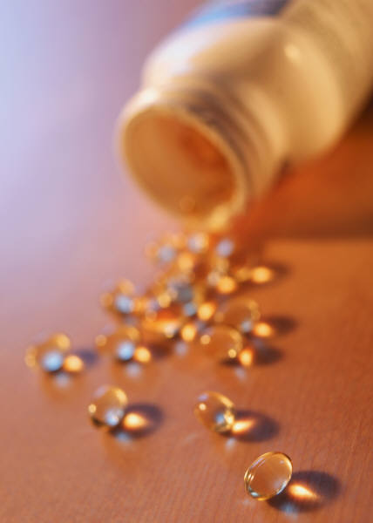

Garden of Life

New Chapter

Mega Foods.

These brands are whole-food sources (not to be confused with the name of the store). Remember, supplements should be used in addition to, not in place of a healthy diet.

NOTE: The suggestions in this booklet are based on the experiences of Linda Kent. She is not responsible for any adverse consequences resulting from any recommendations found in this booklet.

